David Thompson Award 2022

Why National Awards?
- Promote excellence in Geomatics
- Promote unique cadastral and non cadastral applications
- Raise public awareness of Geomatics

Challenging Cadastral Survey Project: Joe Iles, Challenger Geomatics Ltd. Field Notes of Natural Boundary Investigation Hay River Dene Reserve No. 1, for the Kátł’odeeche First Nation, Northwest Territories
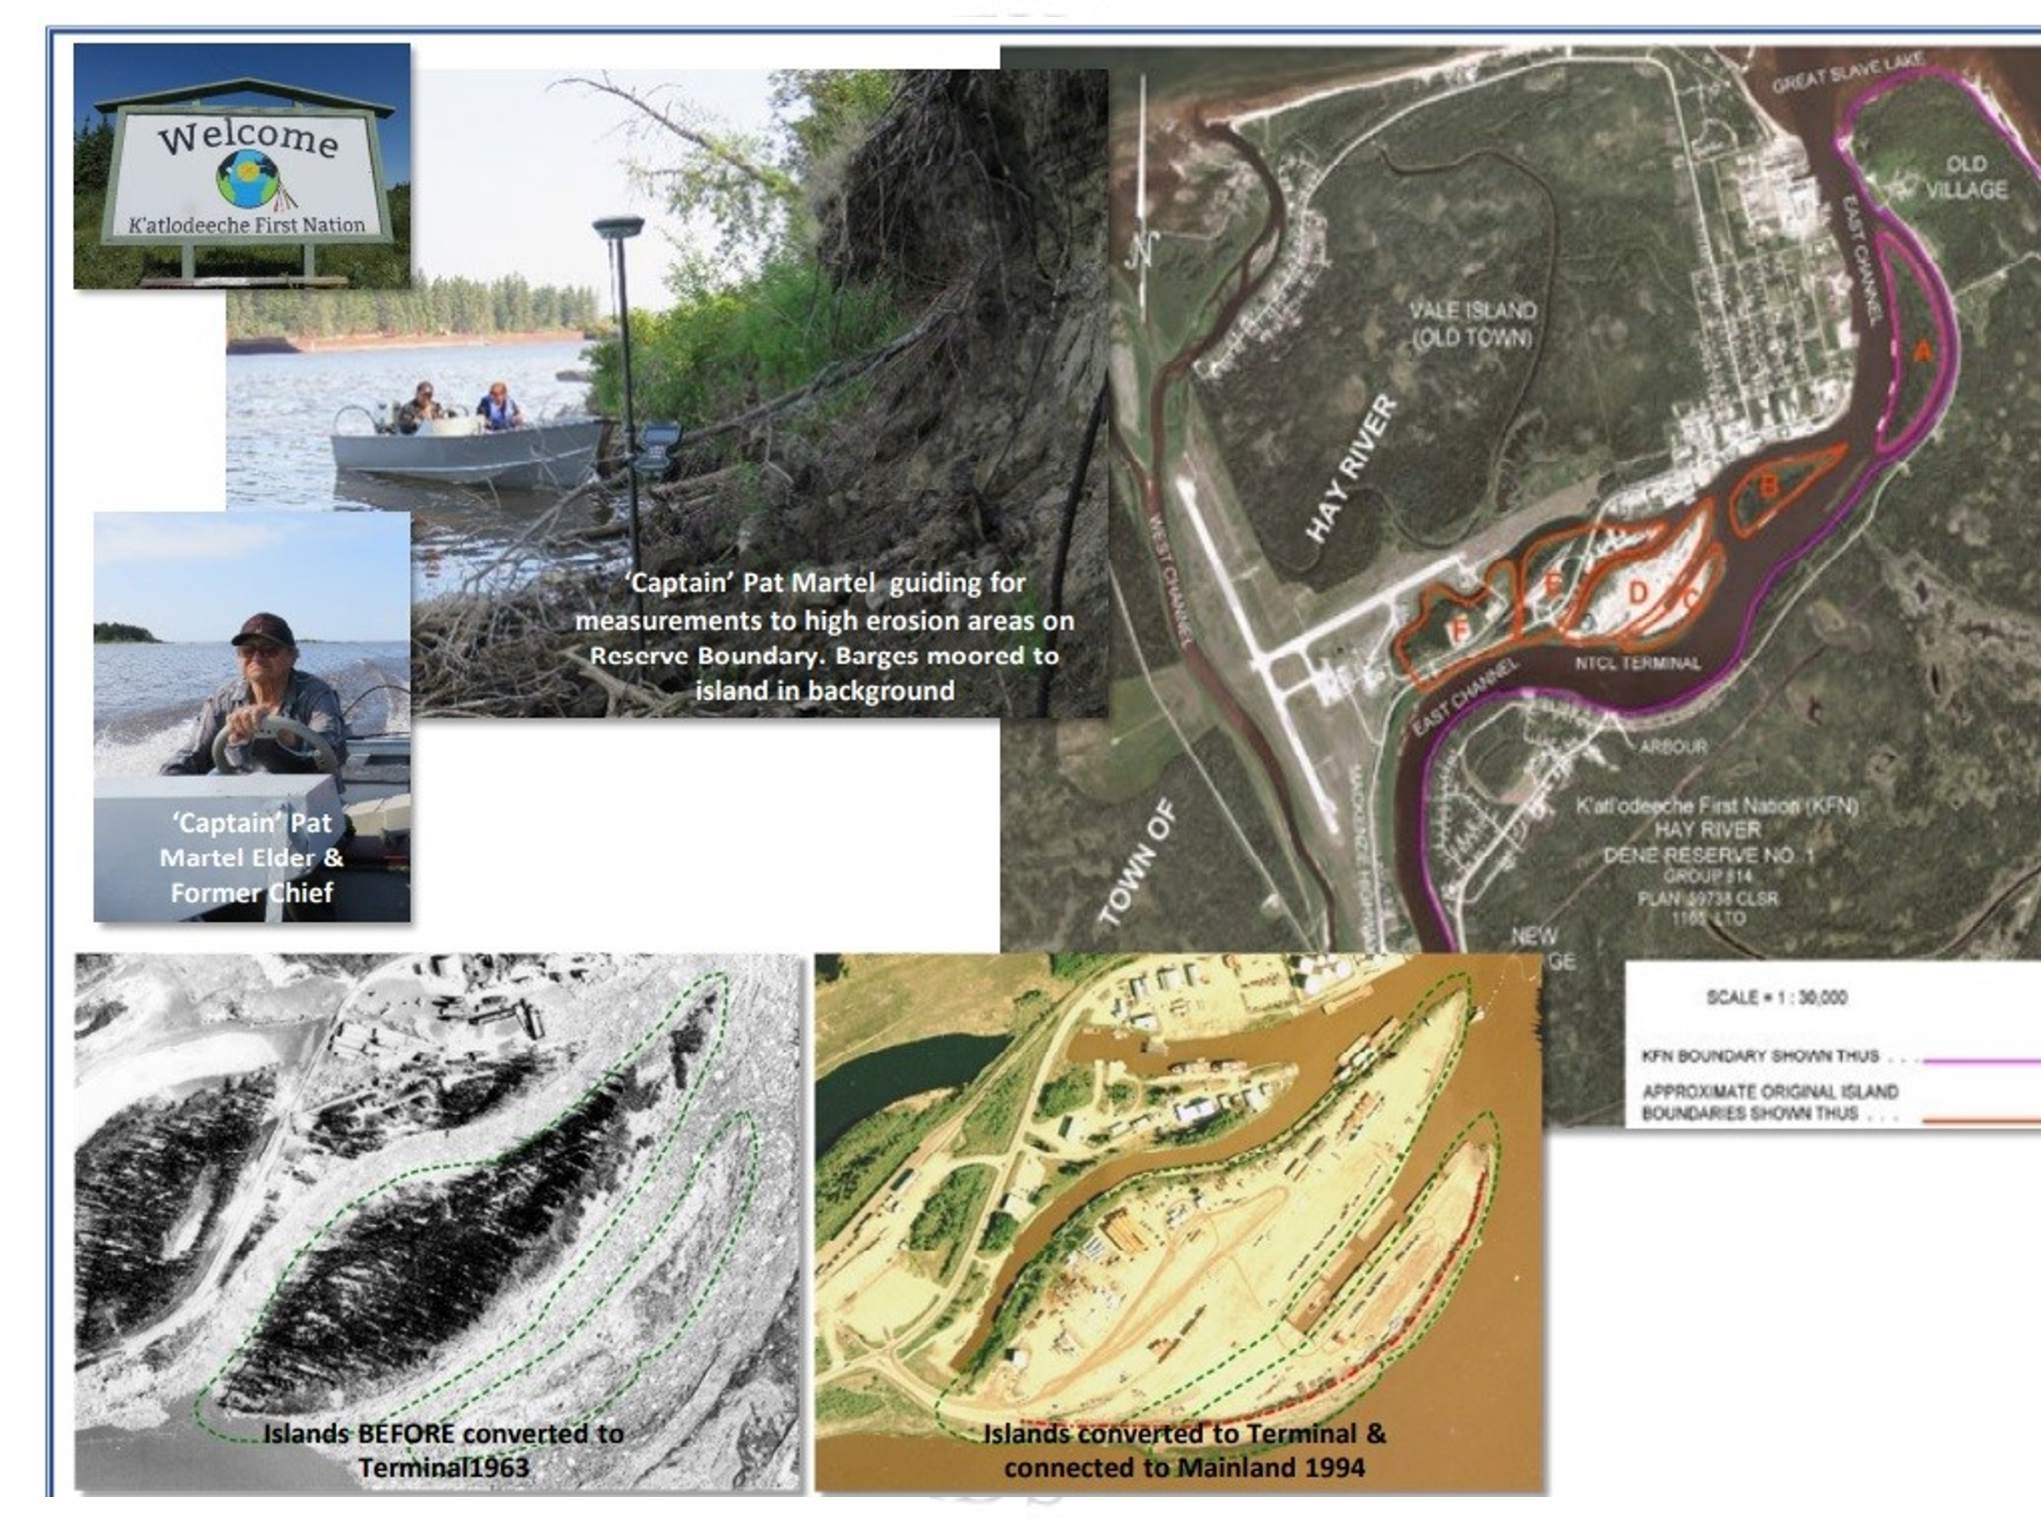

Challenging Non Cadastral Survey Project: Trevor Burton of McElhanney Ltd. High-definition survey of a century-old rail bridge
